Assignment 8

## Rules:

For this assignment you will work in group of two team member, in case you are unable to find partner you can work alone (but you will need my permission). You cannot working in group of more than 2.

You will submit assignment in one. asm file on google classroom (link will be provided soon)

Due data of assignment is: 23rd Dec 2020 (no extension possible as that is last week of classes)

Plagiarism will result in negative marking that will seriously affect your grade and can also result in F

# TREX GAME.

In this assignment you will be creating a T-Rex game. In this game a dinosaur is running and has to jump over the hurdles. The more hurdles it crosses the more it will score.

You can play this game online at <https://elgoog.im/t-rex/> and get familiar with it

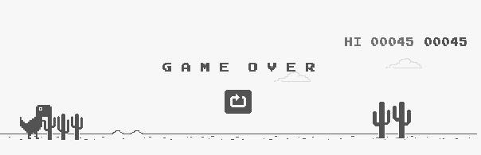

Figure 1: T-rex game screenshot

## After playing it you will observer following things:

* The dinosaur always remain at left side of screen. And the background is actually constantly moving from right to left
* The dinosaur will jump to certain height (still staying at left side of screen) if you press spacebar key and will drop back to same left side of screen.
* If cactus plant or a bird hits dinosaur the game is over
* The change in score is also shown on screen.
* The hurdles are somewhat randomly coming

## How you can create this game in Assembly:

1. To create this game you will hook the keyboard hardware interrupt (int9h), such that whenever space is pressed the dinosaur will jump in place to a certain height and will fall back.
2. You will also hook the time interrupt (int 8h) to continuously move the hurdles from right to left.
   1. We have not covered int 8h in class, however at this point you should be able to read about it and should be able to use it. I would recommend to run example 9.7 and 9.8 from BH to see how int 8h can be used to periodically perform a task
   2. In real game hurdles are random, but you can keep some fixed pattern that repeats over and over (however if you are able to make hurdles random you can get bonus)
3. Work to combine 1 and 2, such that dinosaur can jump and object can move simultaneously. (See example 9.8 of book)
4. You don’t need to TSR your customized ISRs because after game is over the program should end.
5. You also need to changing score on screen all the time as constant place

## Graphics:

* As you are working in text more you might not be able to create the graphics (i.e shape of dinosaur and hurdles) as shown in figure 1. Therefore instead of creating dinosaur you can create and jumping object and hurdles of any shape. Following figure show one option

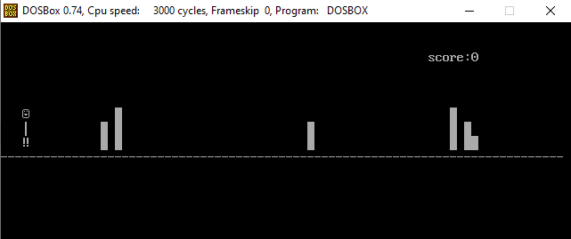

Figure 2: Suggested Graphics, 01h is Ascii for smiley, 13h for !! , DBh for one block, B3h for |, and 2Dh for -. Changing Score should be displayed on screen all the time.

## Open Questions:

The above two sections give description of mandatory task required for this assignments. There are many open questions that you can ask for example to what height dinosaur should jumps to? how fast the hurdles are moving? what to do when game is over? Etc. The answer to all these questions are that you are free to change these things in your design to create an acceptable gaming experience. A simple tip is JUST KEEP IT SIMPLE.

You can use any code given in book, for example clrscrn

## Marks Distribution:

|  |  |
| --- | --- |
| Rubric | % |
| 1. Graphics | 10% |
| 1. Jumping of Dinosaur | 20% |
| 1. Moving of Hurdles | 25% |
| 1. Working of 2 and 3 together such that score increases when hurdle is cleared and game is over when dinosaur jumps over hurdle | 25% |
| 1. Changing Score | 10% |
| 1. Coding | 10% |
| TOTAL | 100% * Viva Score% 1 |
| Bonus (will be given if everything is perfectly working and some extra work is done) | 10% |

1 There will be a viva of each team member to evaluate how much work each has done your assignment score will be multiplied with the % of your viva score